Decision Analysis Concepts

Part 1

[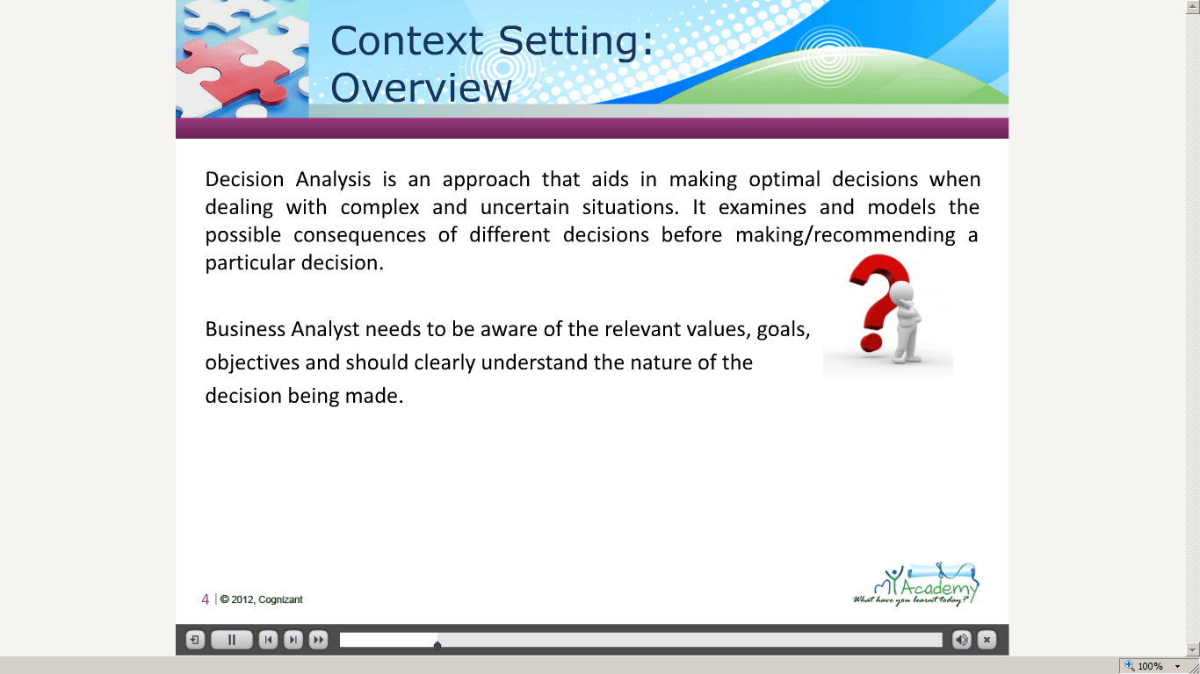](https://compass.learning.cognizant.com/elmprd/elearning/decision_analysis_basiclearning_specialist/decision%20analysis_basiclearning_specialist.htm)

[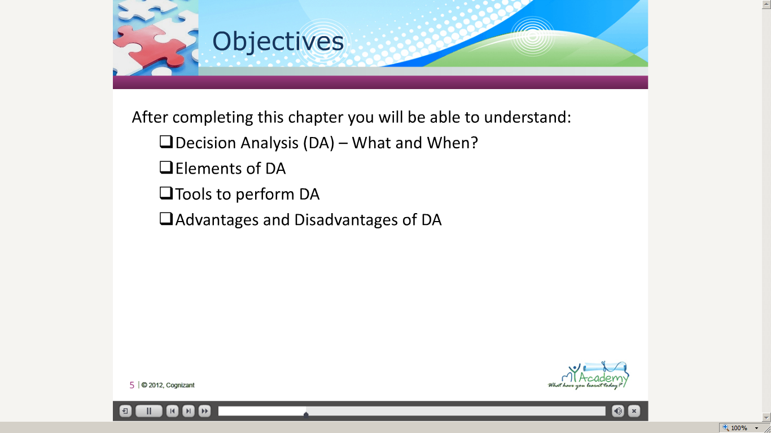](https://compass.learning.cognizant.com/elmprd/elearning/decision_analysis_basiclearning_specialist/decision%20analysis_basiclearning_specialist.htm)

[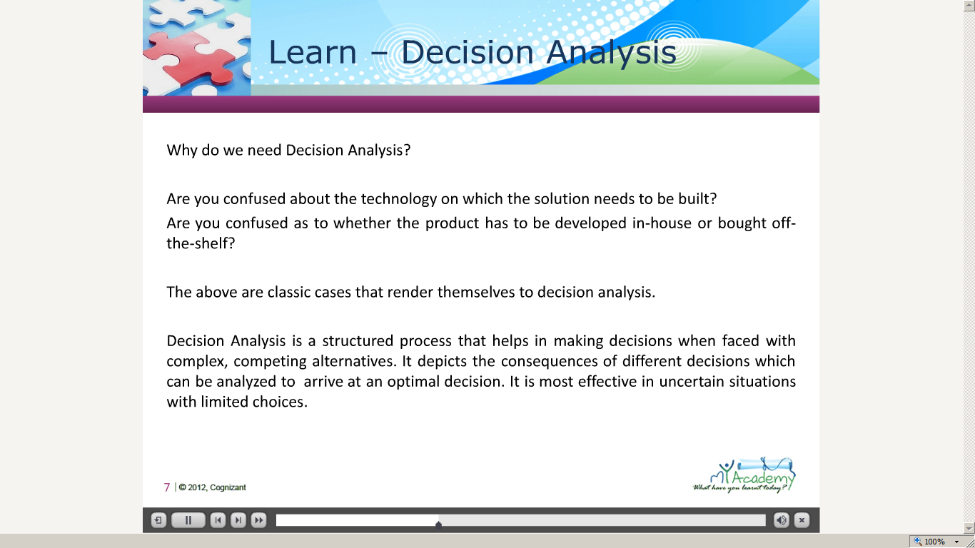](https://compass.learning.cognizant.com/elmprd/elearning/decision_analysis_basiclearning_specialist/decision%20analysis_basiclearning_specialist.htm)

[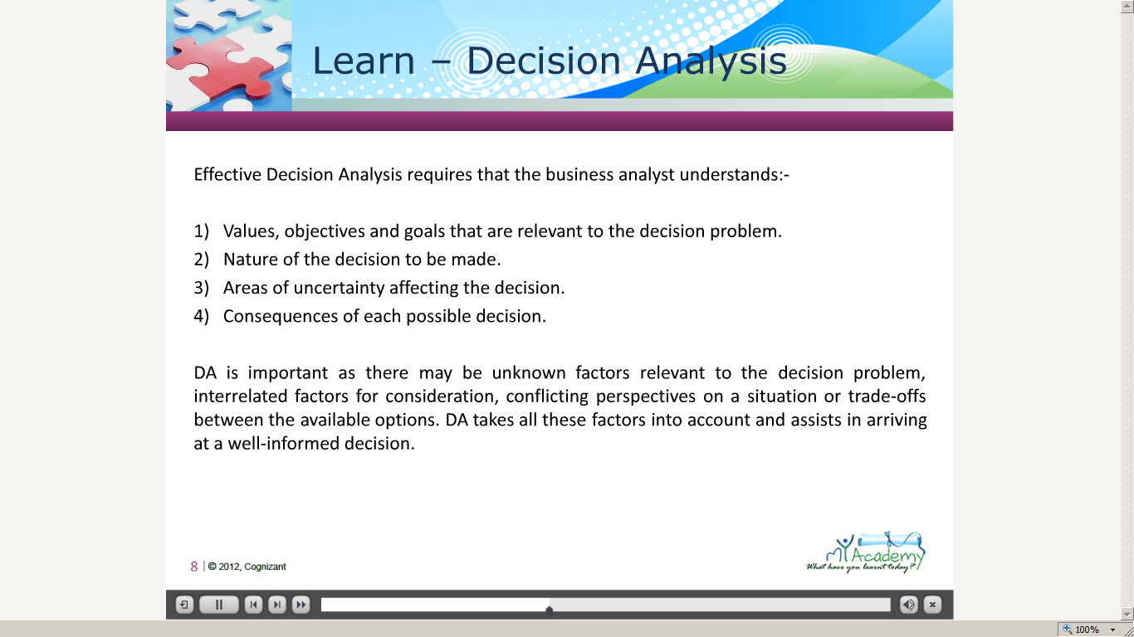](https://compass.learning.cognizant.com/elmprd/elearning/decision_analysis_basiclearning_specialist/decision%20analysis_basiclearning_specialist.htm)

[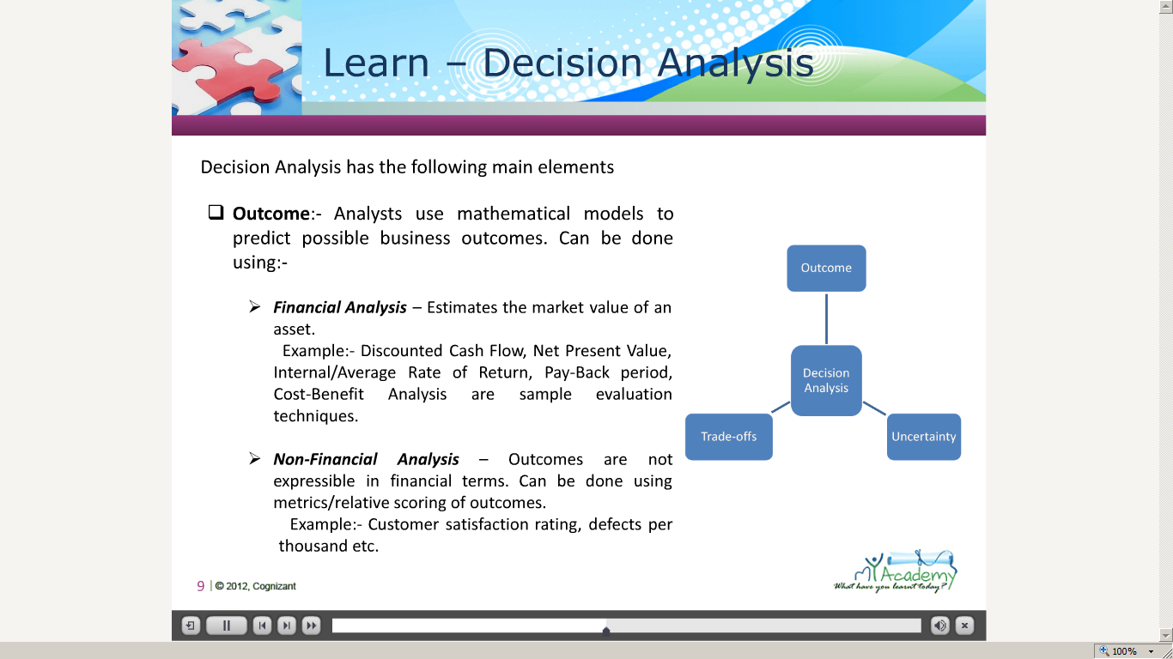](https://compass.learning.cognizant.com/elmprd/elearning/decision_analysis_basiclearning_specialist/decision%20analysis_basiclearning_specialist.htm)

[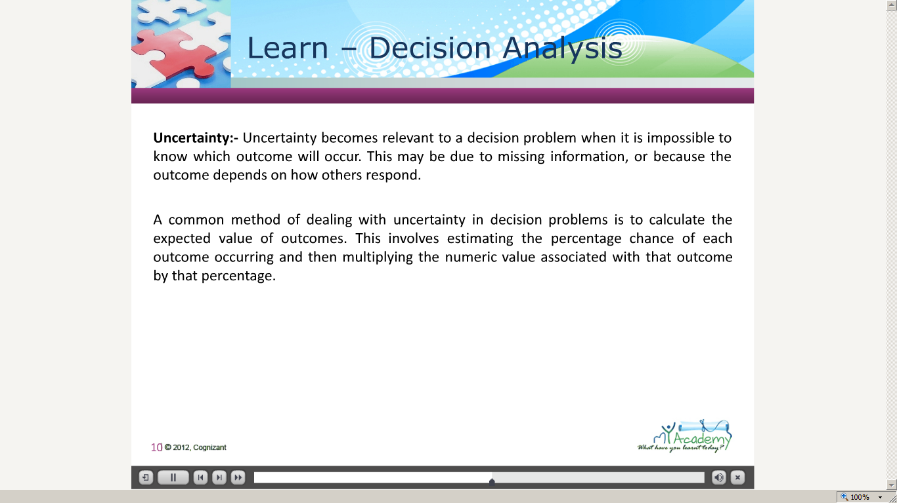](https://compass.learning.cognizant.com/elmprd/elearning/decision_analysis_basiclearning_specialist/decision%20analysis_basiclearning_specialist.htm)

[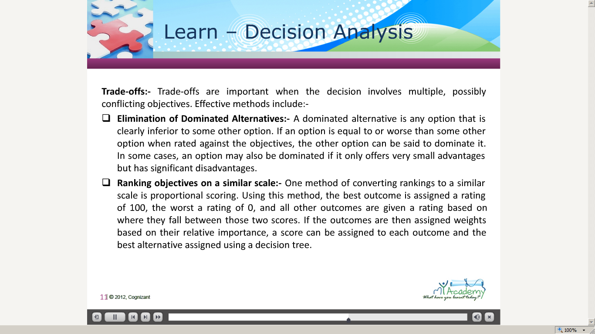](https://compass.learning.cognizant.com/elmprd/elearning/decision_analysis_basiclearning_specialist/decision%20analysis_basiclearning_specialist.htm)

[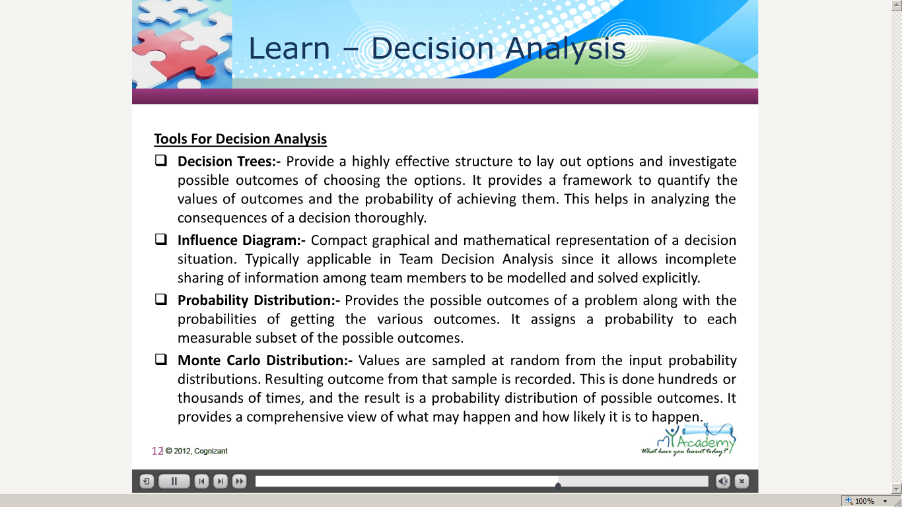](https://compass.learning.cognizant.com/elmprd/elearning/decision_analysis_basiclearning_specialist/decision%20analysis_basiclearning_specialist.htm)

[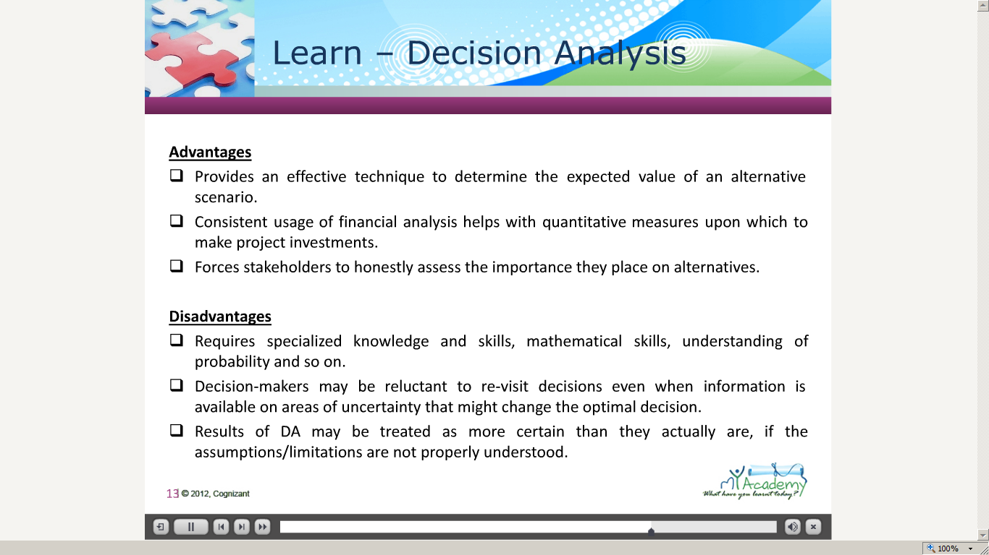](https://compass.learning.cognizant.com/elmprd/elearning/decision_analysis_basiclearning_specialist/decision%20analysis_basiclearning_specialist.htm)

[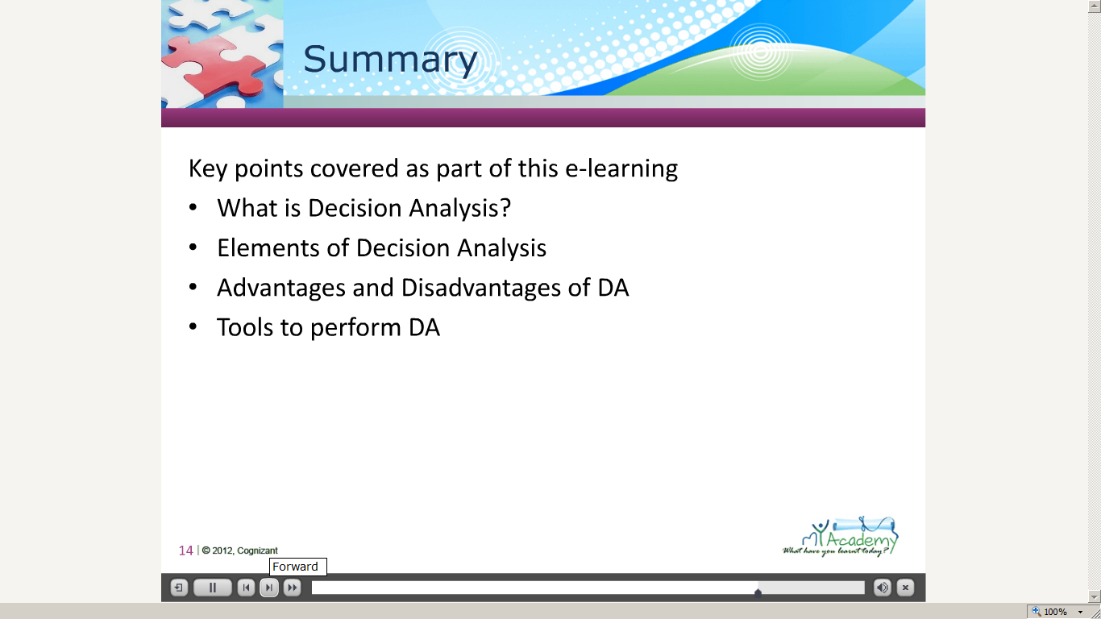](https://compass.learning.cognizant.com/elmprd/elearning/decision_analysis_basiclearning_specialist/decision%20analysis_basiclearning_specialist.htm)

Part 2 case study

[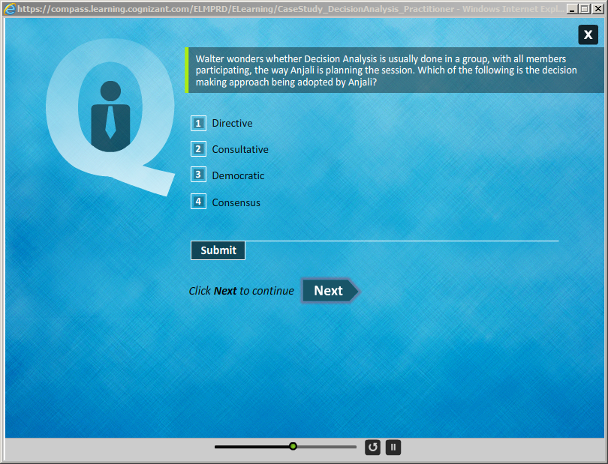](https://compass.learning.cognizant.com/elmprd/elearning/casestudy_decisionanalysis_practitioner/html/course.htm)

[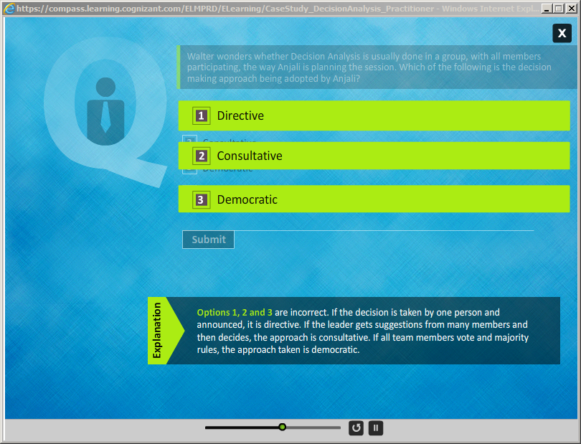](https://compass.learning.cognizant.com/elmprd/elearning/casestudy_decisionanalysis_practitioner/html/course.htm)

[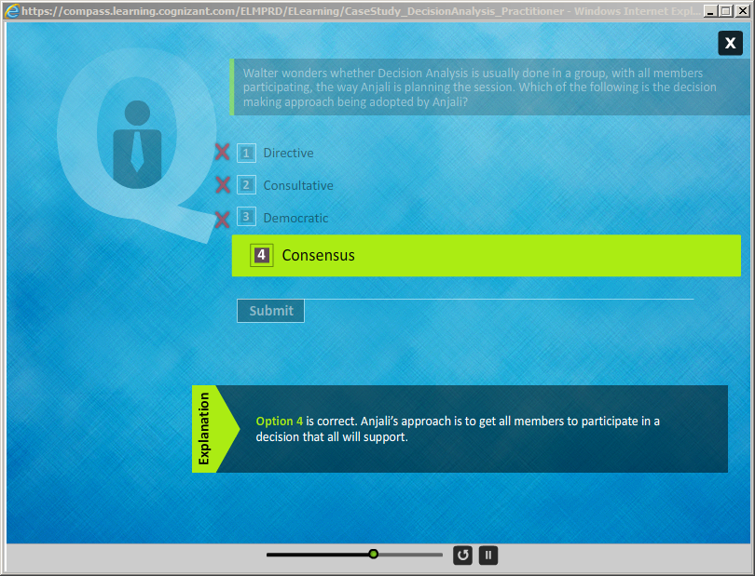](https://compass.learning.cognizant.com/elmprd/elearning/casestudy_decisionanalysis_practitioner/html/course.htm)

[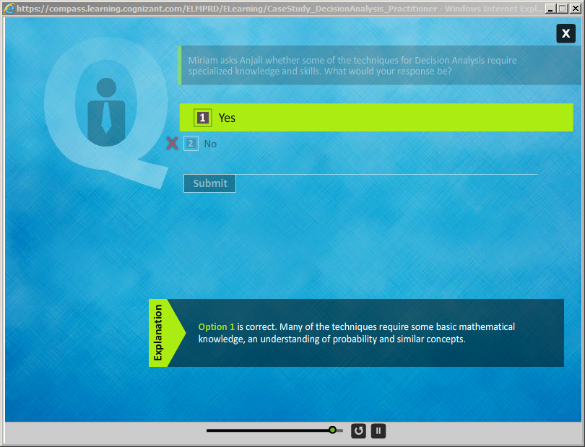](https://compass.learning.cognizant.com/elmprd/elearning/casestudy_decisionanalysis_practitioner/html/course.htm)

[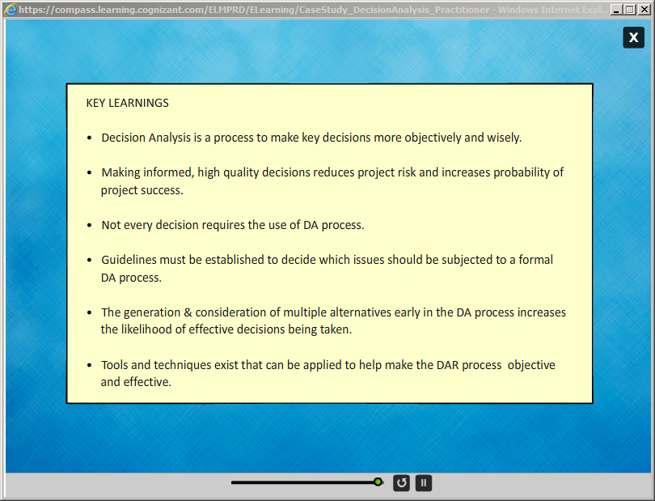](https://compass.learning.cognizant.com/elmprd/elearning/casestudy_decisionanalysis_practitioner/html/course.htm)

Part 3 Case study

[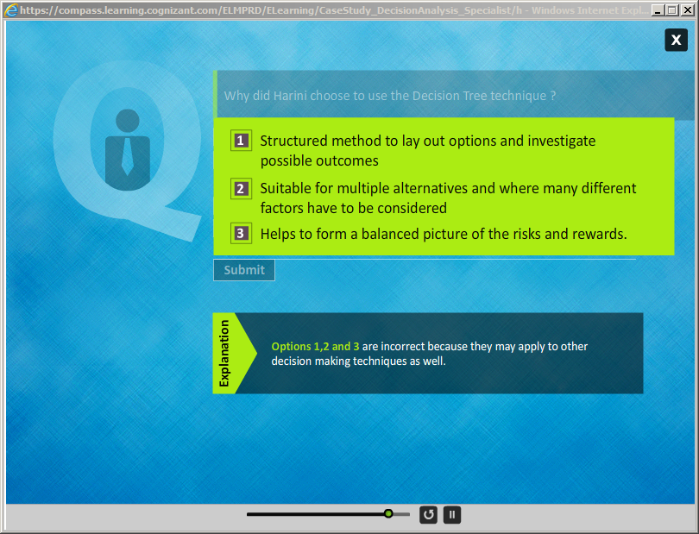](https://compass.learning.cognizant.com/elmprd/elearning/casestudy_decisionanalysis_specialist/html/course.htm)

[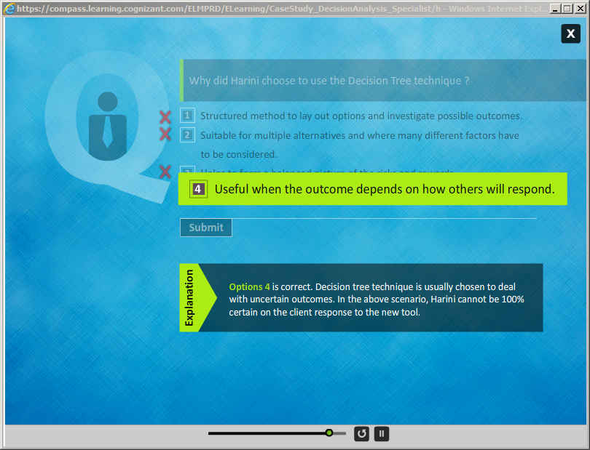](https://compass.learning.cognizant.com/elmprd/elearning/casestudy_decisionanalysis_specialist/html/course.htm)

[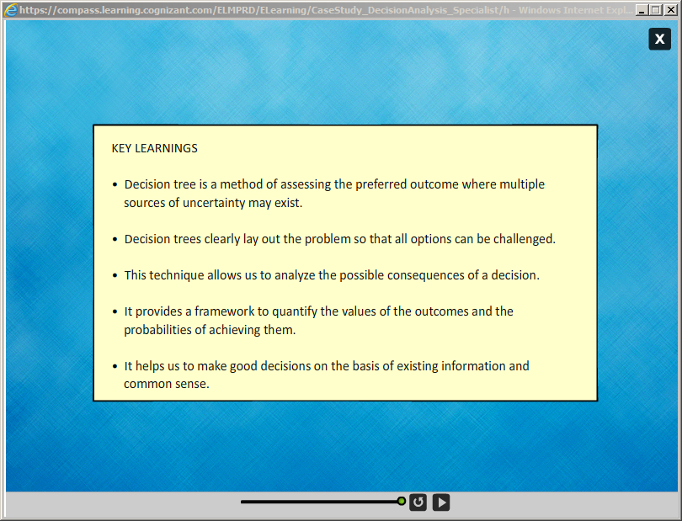](https://compass.learning.cognizant.com/elmprd/elearning/casestudy_decisionanalysis_specialist/html/course.htm)

Part 4 Decision Analysis Quiz

[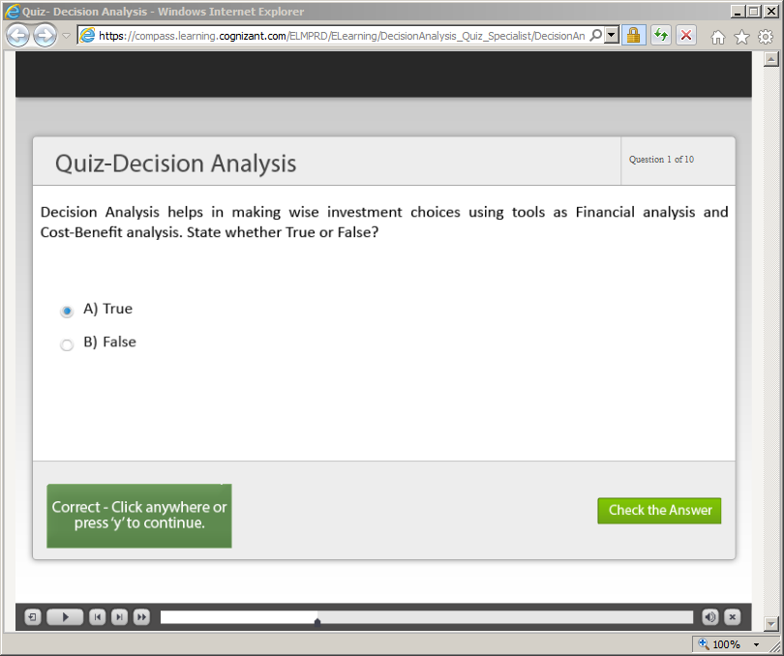](https://compass.learning.cognizant.com/elmprd/elearning/decisionanalysis_quiz_specialist/decisionanalysis_quiz_specialist.htm)

[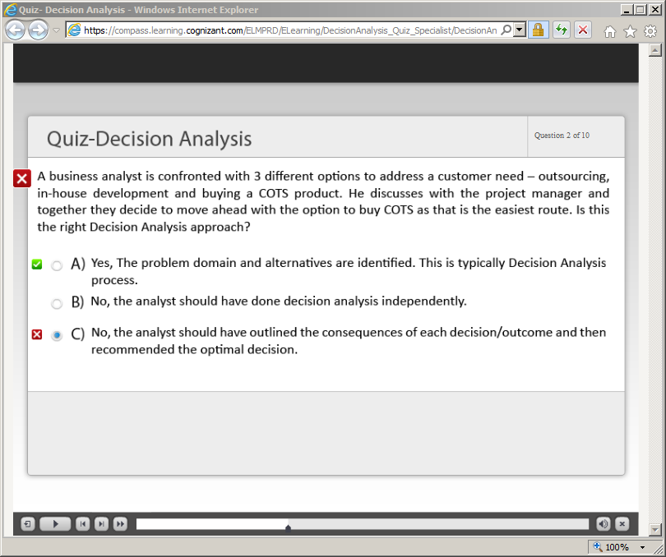](https://compass.learning.cognizant.com/elmprd/elearning/decisionanalysis_quiz_specialist/decisionanalysis_quiz_specialist.htm)

[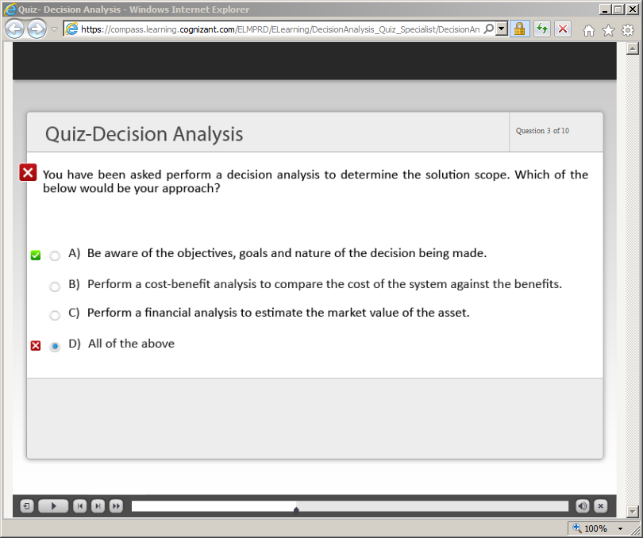](https://compass.learning.cognizant.com/elmprd/elearning/decisionanalysis_quiz_specialist/decisionanalysis_quiz_specialist.htm)

[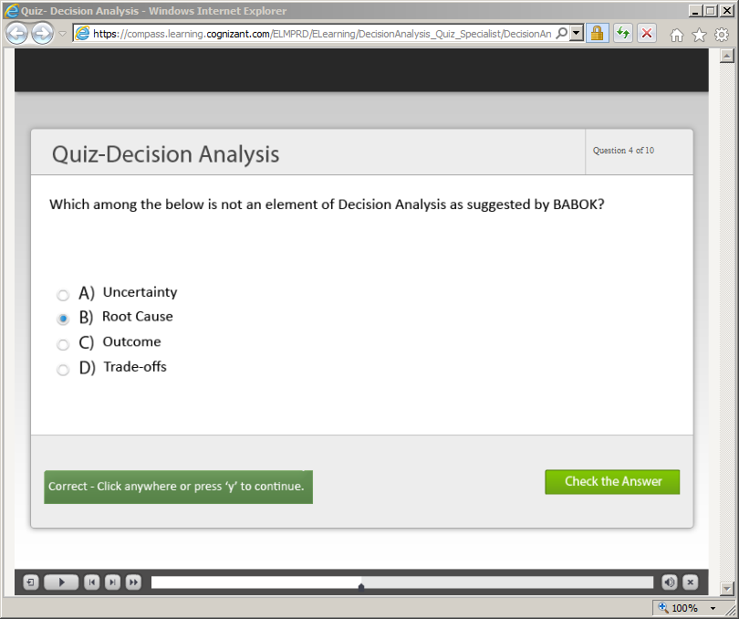](https://compass.learning.cognizant.com/elmprd/elearning/decisionanalysis_quiz_specialist/decisionanalysis_quiz_specialist.htm)

[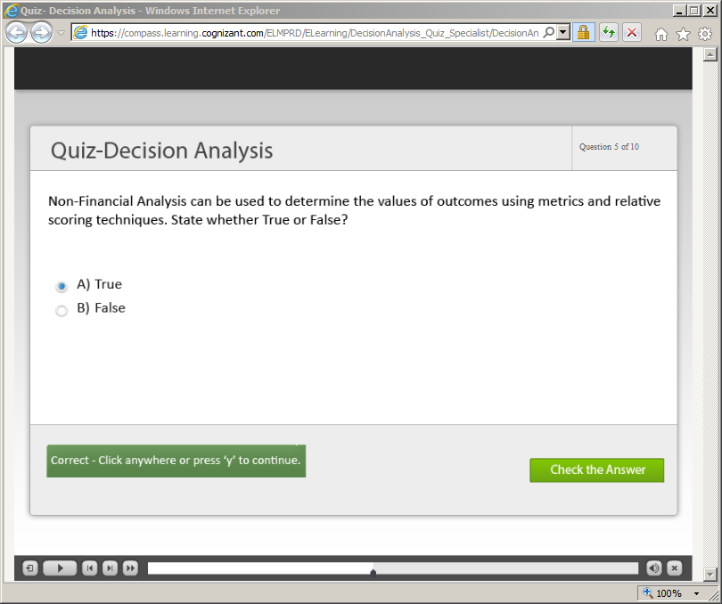](https://compass.learning.cognizant.com/elmprd/elearning/decisionanalysis_quiz_specialist/decisionanalysis_quiz_specialist.htm)

[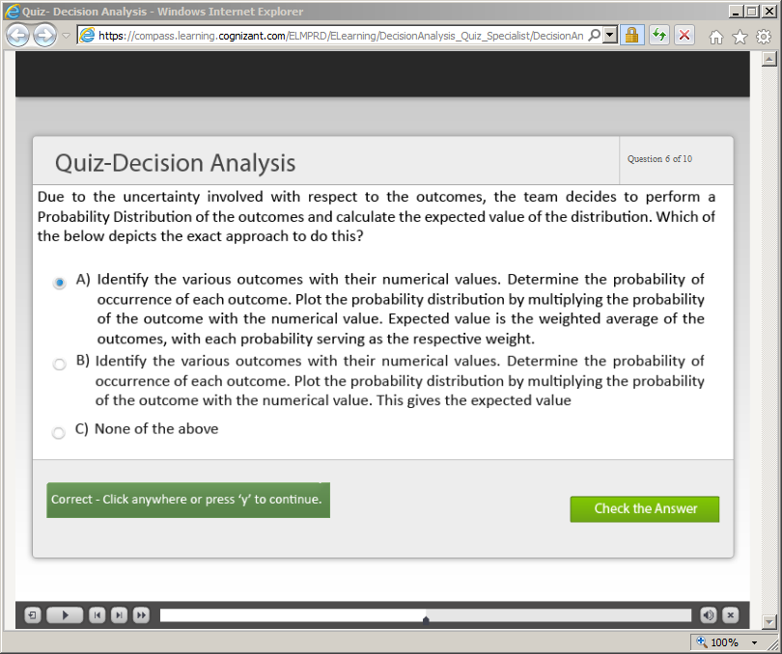](https://compass.learning.cognizant.com/elmprd/elearning/decisionanalysis_quiz_specialist/decisionanalysis_quiz_specialist.htm)

[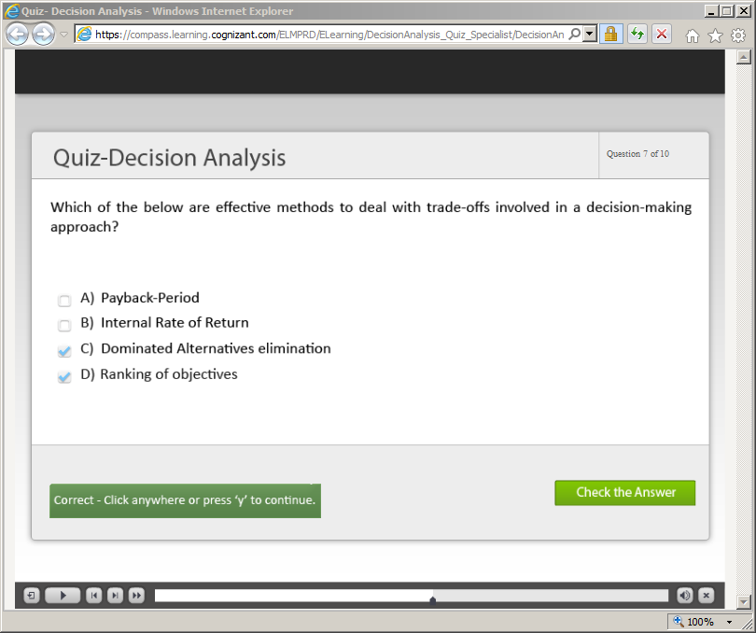](https://compass.learning.cognizant.com/elmprd/elearning/decisionanalysis_quiz_specialist/decisionanalysis_quiz_specialist.htm)

[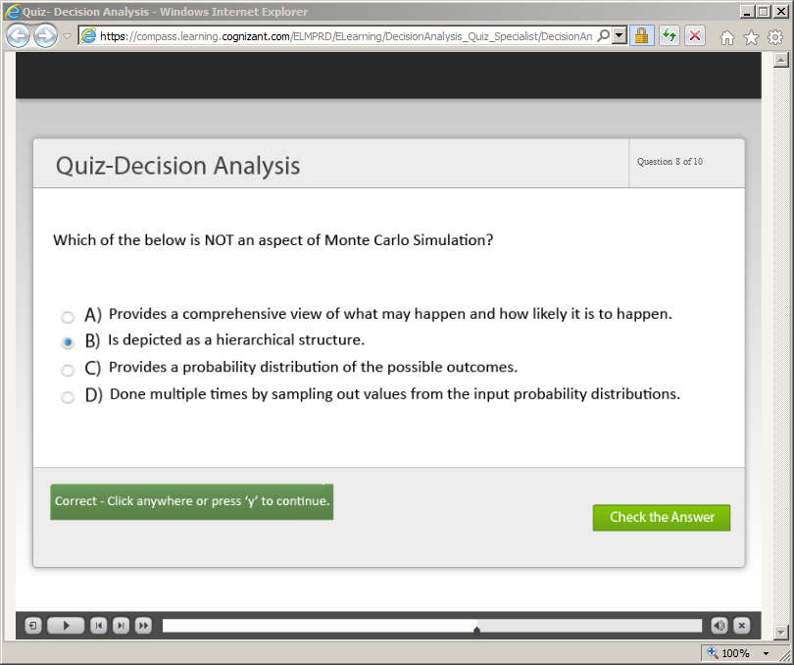](https://compass.learning.cognizant.com/elmprd/elearning/decisionanalysis_quiz_specialist/decisionanalysis_quiz_specialist.htm)

[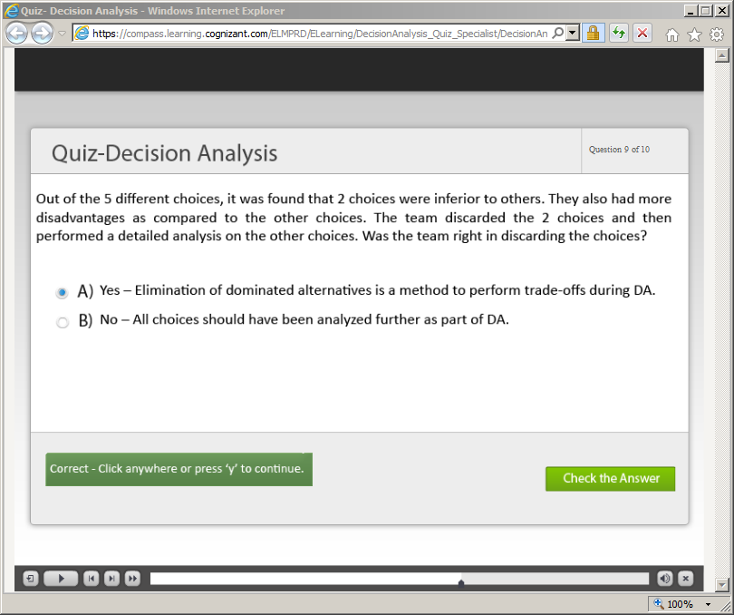](https://compass.learning.cognizant.com/elmprd/elearning/decisionanalysis_quiz_specialist/decisionanalysis_quiz_specialist.htm)

[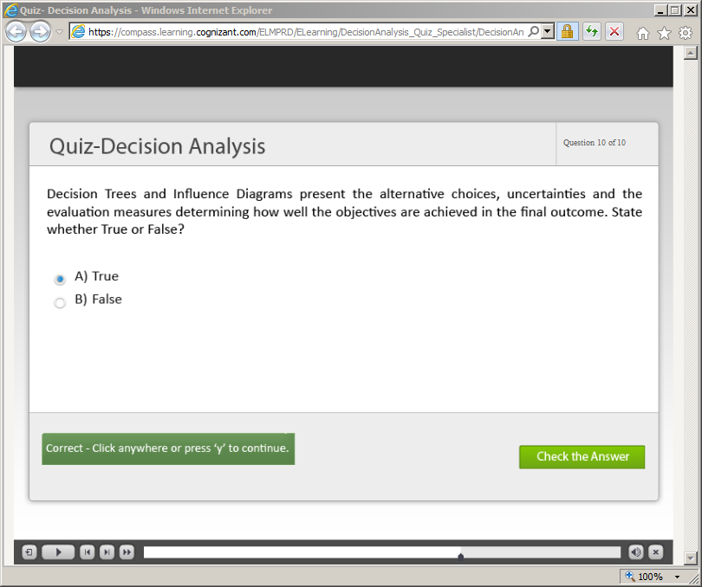](https://compass.learning.cognizant.com/elmprd/elearning/decisionanalysis_quiz_specialist/decisionanalysis_quiz_specialist.htm)